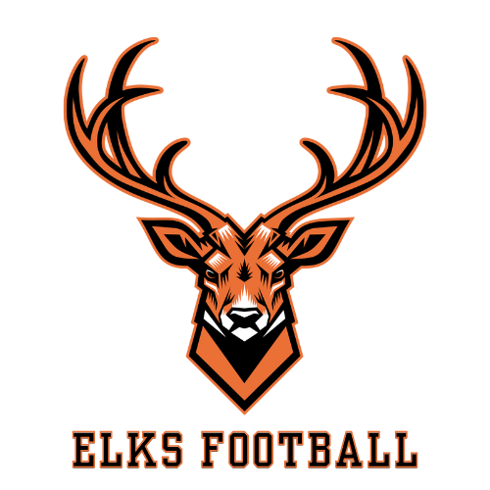

Subject: 2026 Elk Rapids Football “FILL THE FENCE” Sign Sponsorship.

Dear Business Owners & Football Fans,

Coming together is a beginning, staying together is progress, and working together is success.’ – H.Ford
Working together with you, our community, is what the “Fill The Fence” sponsorship program is all about. Over the years, many of you have committed your generous donations directly to our football program which has made all the difference in helping us reach our goals. The players and program are positively affected in ways both seen and unseen. This includes providing safe and up to date equipment, such as the recent purchase of Guardian Caps for all players. We invite you to continue your sponsorship if you have already supported our program financially in the past OR to join us this season as a NEW SPONSOR!. Thank you for your participation!

COMING THIS SEASON: We are thrilled for the return of Adam Trautman Youth Camp on July 1st. While our youth players will participate, our HS players and coaches will help run drills and assist Adam for a program wide experience. In June, HS Players will be participating in two Ferris Based Development Camps. The first is an invite-only camp at Clare High School with a handful of other high schools. We were also able to arrange a customized in-service here at Elk Rapids for our coaches and players led by Tony Anese and Ferris’s coaching staff. Lastly, Join us for the Orange & Black Showcase and Tailgate on Saturday, August 15th beginning at 5:30 pm.

Sponsorship Banners may contain an image, logo or other information that best suits your business. A high resolution PDF of your design in correct size proportions must be emailed to info@elkrapidsfootball.com. Banners will hang on the fence of the Glowicki Field for all of our Youth, Middle School, JV and Varsity games, guaranteeing excellent exposure for your business throughout the season. *PLEASE SEE & RETURN ATTACHED FOR COMPLETE DETAILS

Your logo will also be added as a live link on our website and seen on our social media platforms: @GOELKSFOOTBALL on Instagram, ELK RAPIDS FOOTBALL on Facebook and www.elkrapidsfootball.com

Please reach out to info@elkrapidsfootball.com for any questions you may have. Payments can be made to “ER Football” attn: “Touchdown Account” and then mailed to 308 Meguzee Point Road, Elk Rapids, Michigan 49629 along with the completed form attached. Since we are a 501(c)(3) all donations are tax deductible. If you are submitting your sponsorship AFTER August 1st, please email your intentions and vector logo file as quickly as possible.

Thank you for supporting our program
Head Coach, Nate Butte
Assistant, Monica Malbouef (Text 989-370-2487 for questions or design concerns)
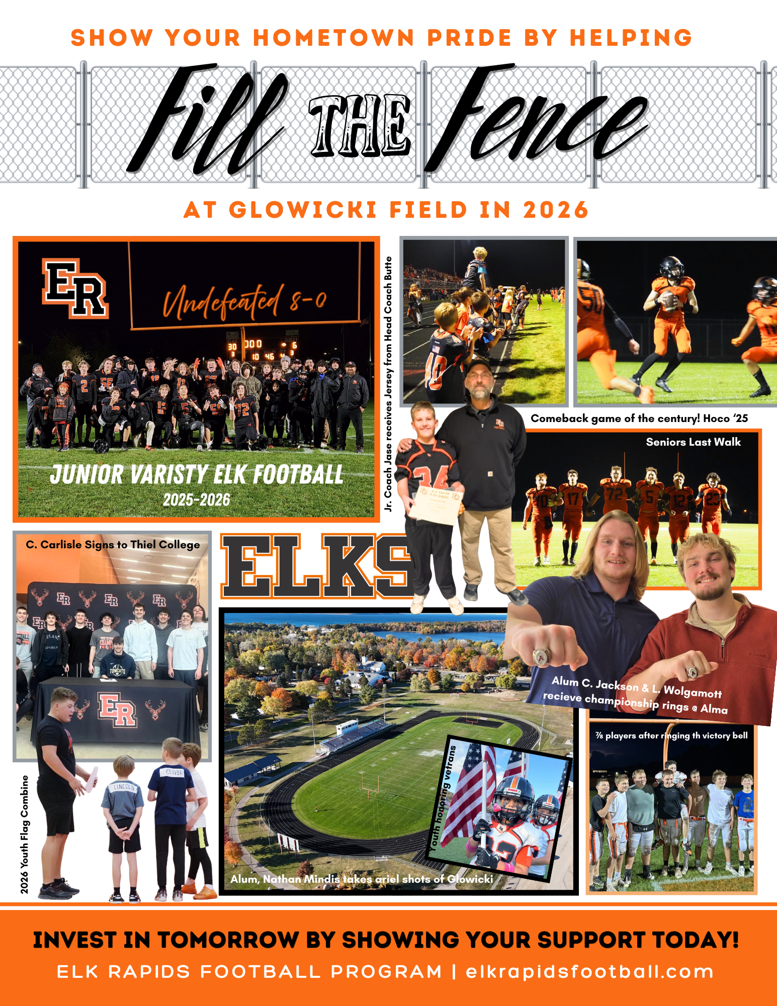

2026 Elk Rapids Football Sign Sponsorship
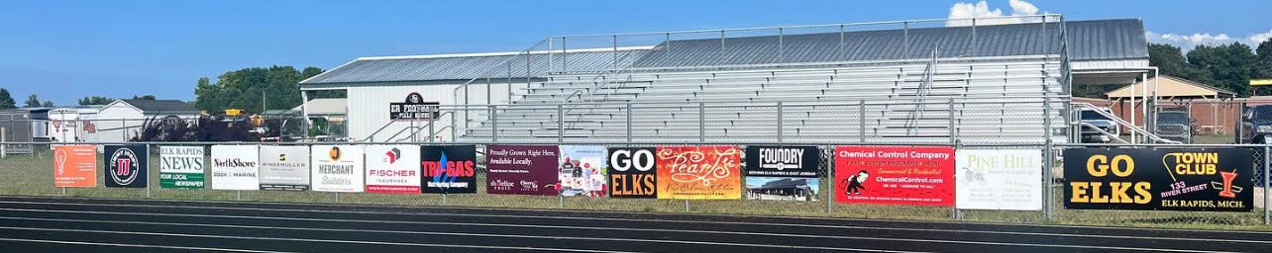
Levels of Sponsorship:
 | SILVER LEVEL | GOLD LEVEL | PLATINUM
Size of Banner | 3’ x 4’ | 3’ x 6” | 3” x 8’
1 Year Sponsorship | $450 | $650 | $850
3 Years Sponsorship | $1,200 | $1,800 | $2,400
5 Years Sponsorship | $2,000 | $3,000 | $4,000

Please complete this form and return with payment before Aug. 1st, 2026 to:
ER Football attn: Touchdown Account | 308 Meguzee Point Road | Elk Rapids, Michigan 49629
**IMPORTANT: Please email INFO@ELKRAPIDSFOOTBALL.COM with your banner design or logo formatted as a PDF file, formatted to the correct proportions of the sign you are selecting.

Have you sponsored ER Football in the past? YES | NO

Please circle the following: SILVER | GOLD | PLATINUM

Please circle the following: 1-Year | 3- Year | 5-Year

Business Name: _____________________________________________________

Business Address:____________________________________________________

Contact Name ______________________________ Phone___________________

Contact Email:_______________________________ TOTAL $INCLUDED_________

Do you need a receipt mailed to you? YES | NO (Your donation is tax deductible

